**Javascript Test**

**TEST NAME: Stopwatch**

**Problem statement**

Create a stopwatch app. Use ONLY vanilla javascript, no libraries or frameworks allowed for Javascript (you can use any css framework like Bootstrap).

**Instructions**

* You are **ALLOWED** to style the app any way you like.
* You are **ALLOWED** to google and read how to approach the problem.
* **DO NOT** copy and paste code from the internet.
* **DO NOT** cheat with other students. ***REMEMBER:*** *These tests are for YOU so that you can learn something new. Cheating won’t help. It’s better to not submit the solution than to cheat and submit. PS: There will be a plagiarism check and when found cheating, you won’t be allowed to give future tests.*
* Once you have finished with the test, make a video recording your computer screen (via phone or a software like OBS/screencastify etc) and **explaining how you have approached the problem** in code **and showing the final product**. The video can be **UPTO 5 mins** long. ***Please don’t record videos longer than that.***
* **Upload** and **Host** the code on github as well.
* Once you have recorded the video, upload it on youtube (unlisted or whatever), drive or wherever you want to upload it and provide the link.
* Hosting on Github is compulsory, I will be rejecting the submission if not hosted!

**(This is just a rough sketch, make it pretty using CSS)**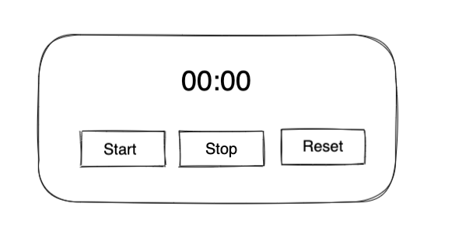

**Features**

* Start timer
  + On click of start button, start the timer
  + If timer is 0 start from beginning else start from wherever last stopped
* Stop timer
  + Stop timer once clicked on the stop button
* Reset button
  + On click of reset stop the watch (if already started) and set timer as 0

**Points on which the project will be judged**

* All functionalities mentioned above
* Github
  + Readme.md file
  + Hosted code on Github
* Code
  + Comments
  + Structuring of code
  + Indentation
  + Variables and functions naming
* Styling
* Hosting
* Design
* Video (explanation about the project)
* Creativity